Advice to Authors for the Preparation of the Final Submission
Full name of 1st author,
Name of 2nd authorª, and
Name of 3rd author – different University (no titles, affiliations etc.)^{b}
ªThe Faculty of Social Sciences
University of name, country
author1@uni.edu
^{b} Name of the institute / department
Name of the University, Country
author3@email.edu
Abstract
The simplest way to follow the guidelines is to replace the text in this file with your own words – using the styles provided as far as possible. This abstract, for example, is 9-point Times New Roman and single-spaced; with 6 pts before and after each paragraph (“Abstract Body”). Papers should be structured as follows: introduction; theory/issues; methods / procedures; results; conclusions; references (replace this file’s first level-headings with this structure). The structure of extended abstracts is flexible but must include an introduction, theory/issues; methods / procedures and a discussion section. The abstract should be between 100 and 150 words.
Keywords: keyword 1; keyword 2; ... (3-6 keywords must be included here).

Originality
All papers are assumed to be original and not under consideration for publication elsewhere. Authors will need to sign a transfer of copyright before an accepted paper is included in the conference proceedings.

Writing Style
The paper must be written in the third person and in English. Authors should use straightforward declarative sentences, making every effort to help readers understand the concepts presented. Please explain any acronyms or abbreviations clearly.

Manuscript Length
Your manuscript must not exceed 20 formatted pages in total for full papers and 5 pages for extended abstracts. If relevant, please remove Endnote fields and turn off the track changes feature of Microsoft Word before submitting your draft paper.
At the final paper stage, please address the recommendations of reviewers in preparing your final paper, as they will decide whether your paper is accepted or is rejected.

Printing Area
Please use A4 sized paper and use Page Setup to set the text area to a single column measuring 12.2 x 19.4 cm. On A4 paper, this equates to top and bottom margins of 5.15cm and left and right margins of 4.4cm. At least two lines of text should follow headings at the bottom of each page; otherwise the heading should be moved to the subsequent page. There should be no running headers or footers.

Typeface and Size
Authors must use Times New Roman typeface. Please do not use a sans-serif typeface for running text, except for computer programs. Mathematics must be typed. Equations numbered for cross-referring should be displayed and centred, with the equation numbers set in parentheses and placed flush right, e.g.
(1)
Always justify the text to occupy the full line width, so that the right margin of a paragraph is not ragged. For running text, please use 10-point type size and single line spacing. Small print (abstract, figure legend, table legend, and references) should be in 9-point type size with 10-point line distance. Please use italics (rather than bold or underlining) to emphasise words in running text.

Headings
Please see the table below for details of how to format headings.
Table 1. Headings
Heading level | Example | Type size, style and line spacing | Paragraph Spacing
Title (centred) | Type Theory | Title case, 14 point, bold font | 0 point before, 6 point after, single spaced
Author's name (centred) | R. L. Constable | Title case, 10 point, normal font | 6 point before and after, single spaced
1st-level heading | 1 Introduction; References | Sentence case, 12 point, bold font | 12 point before and 6 point after, single spaced
2nd-level heading | 2.1 Heading | Sentence case, 10 point, bold font | 6 point before and after, single spaced
3rd-level heading | Typing rules. Text follows | Sentence case, 10 point, bold font | 6 point before and after, single spaced
4th-level heading | Remarks: Text follows | Sentence case, 10 point, italic font | 6 point before and after, single spaced
Normal text | This is an example of normal text. | Sentence case, 10 point, normal font | 6 point before and after, single spaced
Figure heading (centred) | Fig. 2. An example | Sentence case, 10 point, , bold font for word “Fig” and number | 6 point before, 12 point after, single spaced
Table heading (centred) | Table 1. An example | Title case, 10 point, bold font for word “Table” and number | 12 point before and after, single spaced
Table text | This is an example of text in a table. | Sentence case, 9 point, normal font | 0 point before and after, exactly 10 pt spacing
Reference text | O’Connor, P. (2007) An analysis of trademark abuse | 9 point, mixed font | 0 point before and after, exactly 10 pt spacing, hanging indent 0.95 (0.4”)

Tables and Figures
Tables and figures should be incorporated directly into the text, careful centred between the margins specified above. Larger tables or figures may be presented in landscape format. All tables, figures or other illustrations should be original. Please do not incorporate material scanned from other sources. A figure or table may precede the reference to it in the text. No figure or table should be after the References section.
Figures. Normally, figures will be black line reproductions. Minimum line weight should be 0.25 mm, while the minimum size of any lettering should be 9-point. Please number figures consecutively (word "Fig." and the number of the figure in bold). Centre the legends below the figures using 10-point type as shown in the example below.
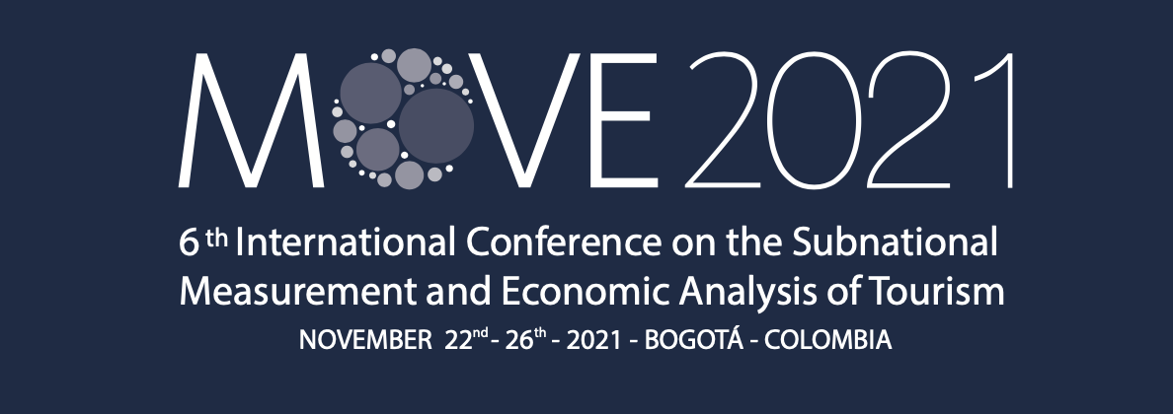
Fig. 1. MOVE 2021 logo
Tables. Type all parts of tables in 9-point type and exactly 10-point line spacing; an additional 2 points may be added to separate parts of the table to show groupings of data. Centre table captions above tables (word “Table” and number of the table in bold – as shown in the example on previous page). Centre tables on the page and number tables consecutively. Please use Arabic (1, 2, 3) rather than Roman (I, II, III) numerals. Always type the word “Table” in full when making reference to it in the text.

Itemised Lists
“Bulleted lists” may be used sparingly in the following format:
- First item. If it is very long long long long long long long, it should wrap nicely as in this example.
- Another item.
- Last Item.

Page Numbering
Do not include page numbers.

Referencing and Citation
Cite references in the text using the APA Publication Manual (5th Edition, cf. e.g. owl.english.purdue.edu/handouts/research/r_apa.html [March 3, 2007]). All citations mentioned in the text should be included in the reference list, and vice-versa. Citations such as “personal communication” should not be in the reference list. Instead they should be added parenthetically in the text. Electronic references should also follow the inline citation system, e.g., more information can be found on www.w3.org [Sept. 9, 2005], or: Many people say that the sky is blue (www.w3.org [Sept. 9, 2005]).
The reference list, placed at the end of the text, should be spaced at exactly 10-point line spacing, with a hanging indent of 0.95cm and use a 9-point font size. Please use italics rather than underlining for emphasis.

References
Espinosa, N. (2014) Global Benchmarking for City Tourism Measurement. Madrid: UNWTO.
INRouTe & UNWTO (2012). A Closer Look at Tourism: Sub-National Measurement and Analysis – Towards a set of UNWTO Guidelines. Madrid: UNWTO.
INRouTe & UNWTO (2015). A Closer Look at Tourism: Sub-National Measurement and Analysis – Regional Tourism: Basic Glossary. Madrid: UNWTO.

Acknowledgements
Please be brief.

